LAB EXPERIMENTS
TOPIC 4
NAME: CHANDRA KALA TORAM
REG NO: 192372224
COURSE CODE: CSA0608
COURSE NAME: DESIGN AND ANALYSIS OF ALGORITHM

Topic 1: Closest Pair of Points (Brute Force Approach)
1.Write a program that finds the closest pair of points in a set of 2D points using the brute force approach.
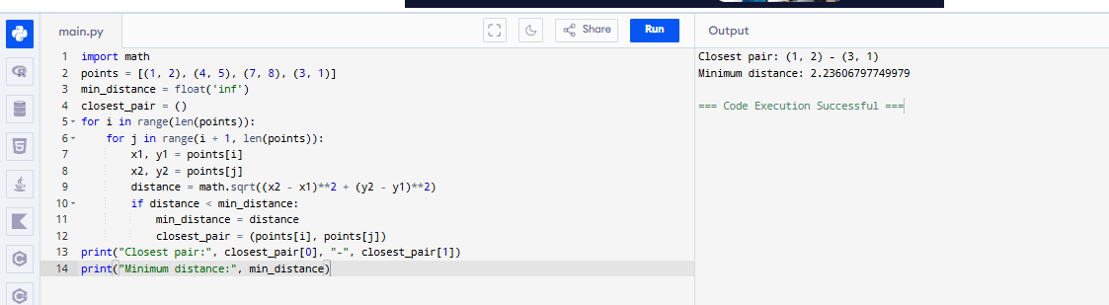
2. Write a program to find the closest pair of points among the given set of coordinates using exhaustive comparison of all pairs.
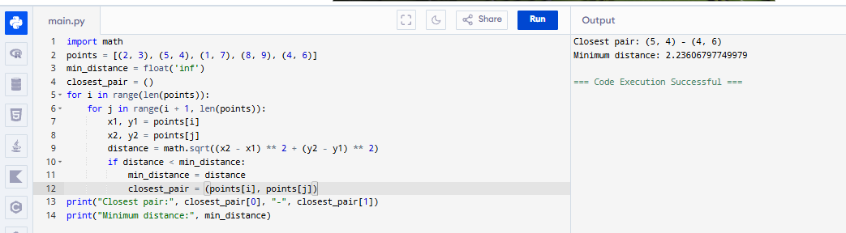
3. Develop a program to calculate the shortest distance between any two points using the brute force closest pair algorithm.
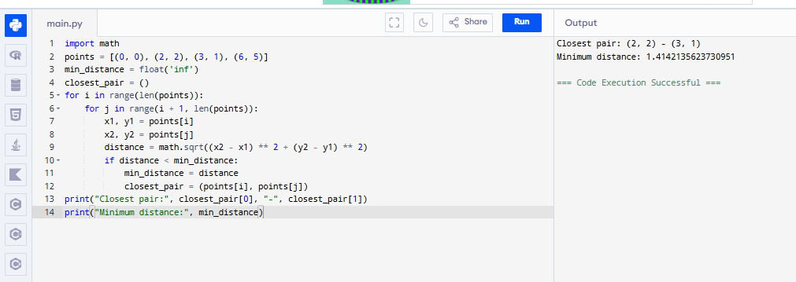
4. Write a program to identify the closest pair of points from a given collection of 2D points using brute force technique.
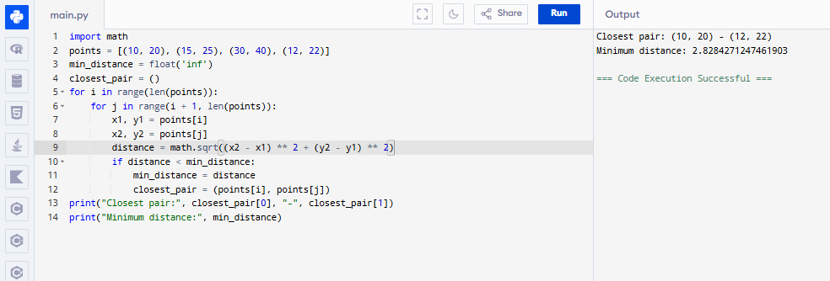
5. Write a program to find the closest pair of points in a given set using the brute force approach. Analyze the time complexity of your implementation. Define a function to calculate the Euclidean distance between two points. Implement a function to find the closest pair of points using the brute force method. Test your program with a sample set of points and verify the correctness of your results. Analyze the time complexity of your implementation. Write a brute-force algorithm to solve the convex hull problem for the following set S of points? P1 10,0) P2 (11,5)P3 (5, 3)P4 (9, 3.5)P5 (15, 3)P6 (12.5, 7)P7(6, 6.5)P8 (7.5, 4.5).How do you modify your brute force algorithm to handle multiple points that are lying on the same line?
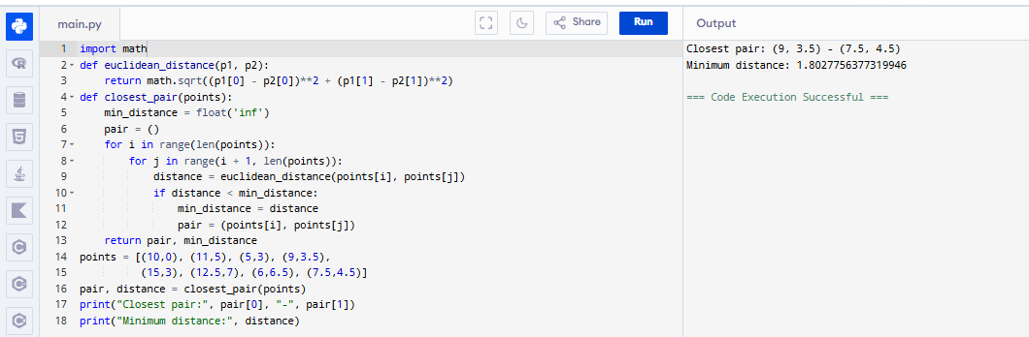

Topic 2: Convex Hull (Basic Method)
6. Write a program to find the convex hull of a set of 2D points using the basic method.
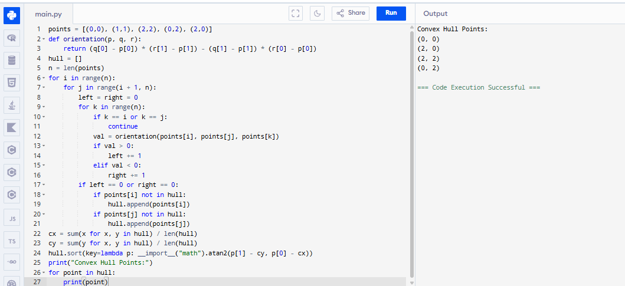
7. Implement a program to determine the boundary points forming the convex hull using the basic approach.
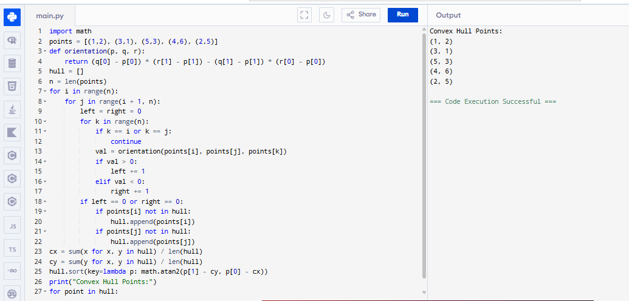
8. Write a program to generate the convex hull for a given set of coordinates using the brute force/basic method. 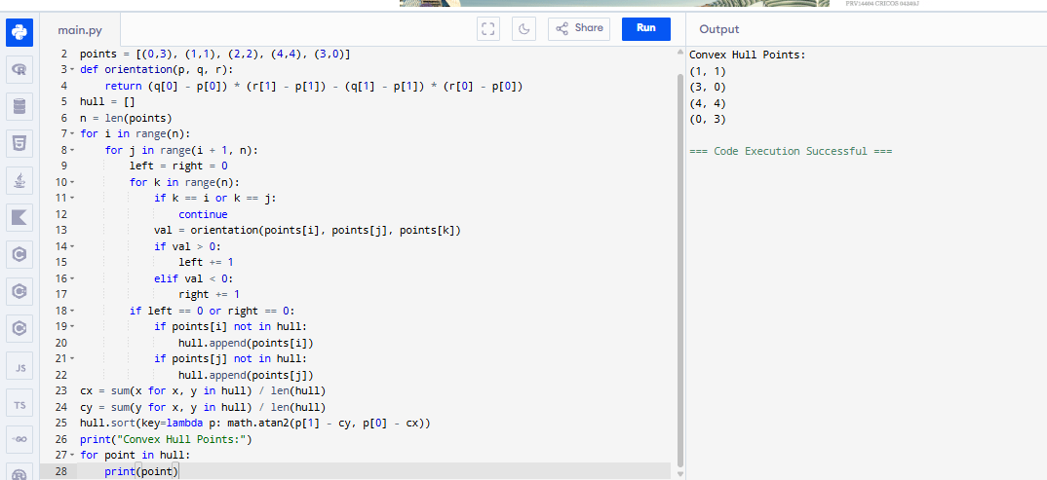
9. Develop a program to find the outer boundary of a set of points using the convex hull Algorithm.
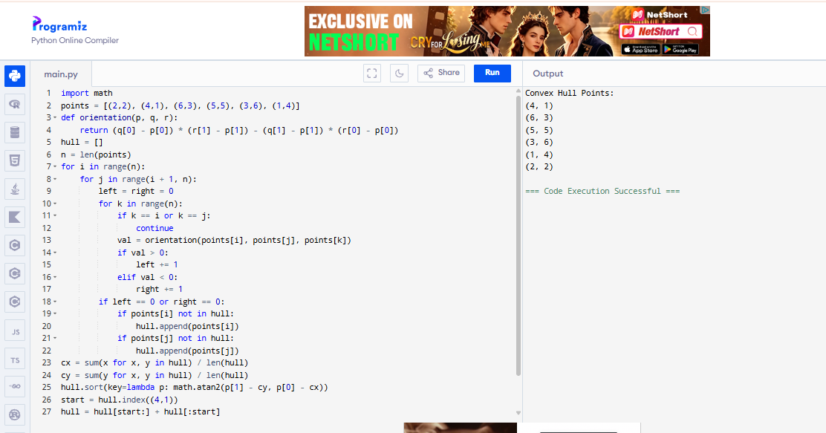
10. Write a program to calculate the convex hull of given points and display the points forming the polygon boundary.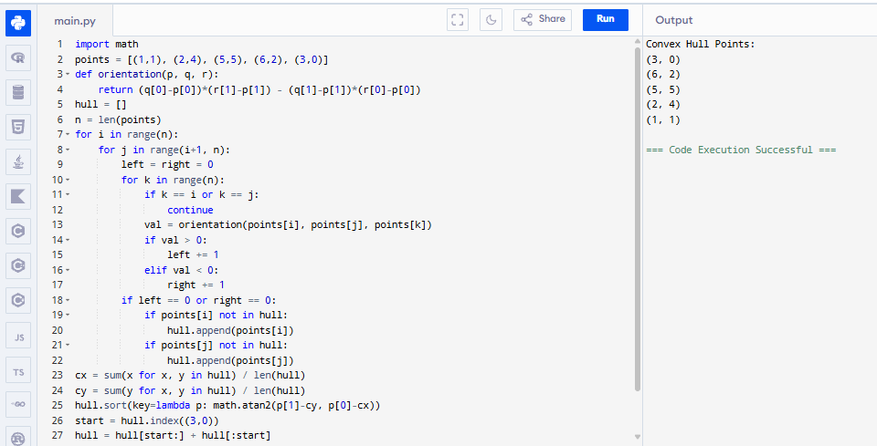
Topic 3: Exhaustive Search for Subset Sum
11. Write a program to find whether a subset exists with a given sum using exhaustive search technique.
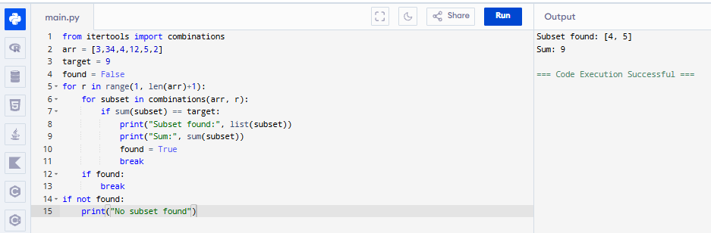
12. Include test cases with different city configurations to demonstrate the program's functionality. Print the shortest distance and the corresponding path for each test case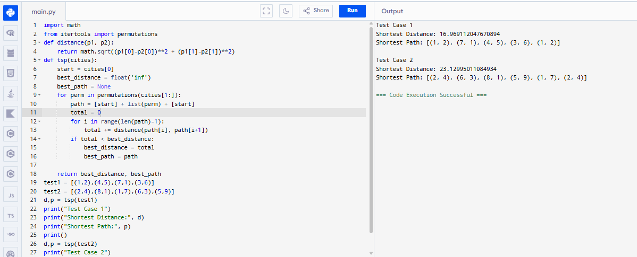
13. You are given a cost matrix where each element cost[i][j] represents the cost of assigning worker i to task j. Develop a program that utilizes exhaustive search to solve the assignment problem. The program should Define a function total_ cost(assignment, cost_ matrix) that takes an assignment (list representing worker-task pairings) and the cost matrix as input. It iterates through the assignment and calculates the total cost by summing the corresponding costs from the cost matrix Implement a function assignment_ problem (cost _matrix) that takes the cost matrix as input and performs the following Generate all possible permutations of worker indices (excluding repetitions).
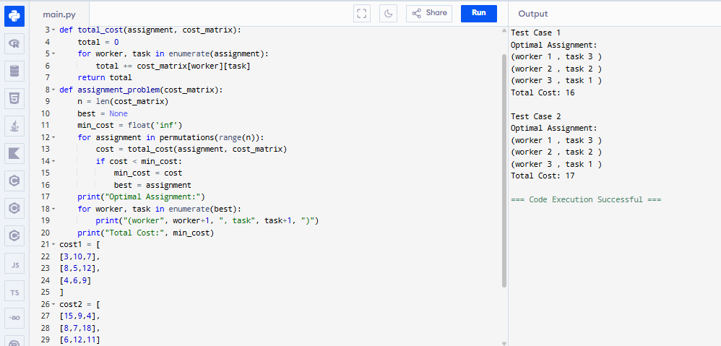
14. You are given a list of items with their weights and values. Develop a program that utilizes exhaustive search to solve the 0-1 Knapsack Problem. The program should:
1. Define a function total_value(items, values) that takes a list of selected items
(represented by their indices) and the value list as input. It iterates through the
selected items and calculates the total value by summing the corresponding values
from the value list.
2. Define a function is_feasible(items, weights, capacity) that takes a list of
selected items (represented by their indices), the weight list, and the knapsack
capacity as input. It checks if the total weight of the selected items exceeds the
capacity.
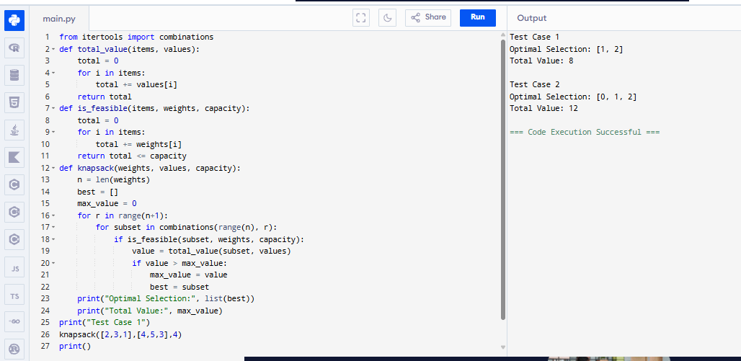
15. Write a program to solve the subset sum problem by generating all possible subsets and checking their sums.
